**Acceptance Testing**

|  |  |
| --- | --- |
| Team ID | PNT2022TMID47935 |
| Project Name | Real-time river water quality monitoring and control system |

**UAT Execution and Report Submission**

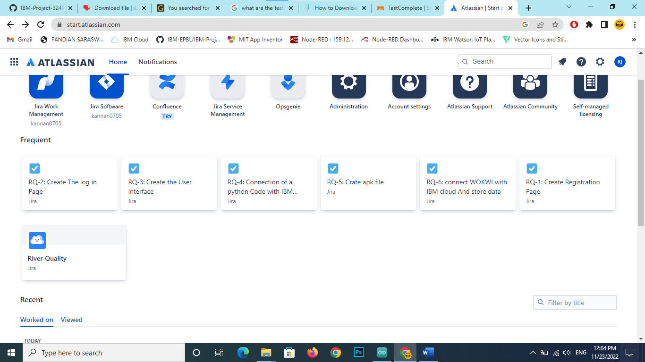

* We are collecting the data from the sensor nodes.
* We have to setup the IBM cloud connection configuration in Node-RED platform
* Then it can connect the IBM Watson IoT with Node-RED platform
* Then the data are transferred to IBM Watson IoT platform
* We have to design and develop the app for our needed works.
* And connect the app with Node-RED
* So, it can easily show the real time water’s pH and Turbidity values in our mobile app
* If we want to close the particular dam, we needed motor controller.
* So, we made a motor controller in our own mobile app.
* The controller’s results are shown in Node-RED